Nehemiah
Part 2 – Chapter 1

- Background
  - Timeframe: 446 BC – 424 BC

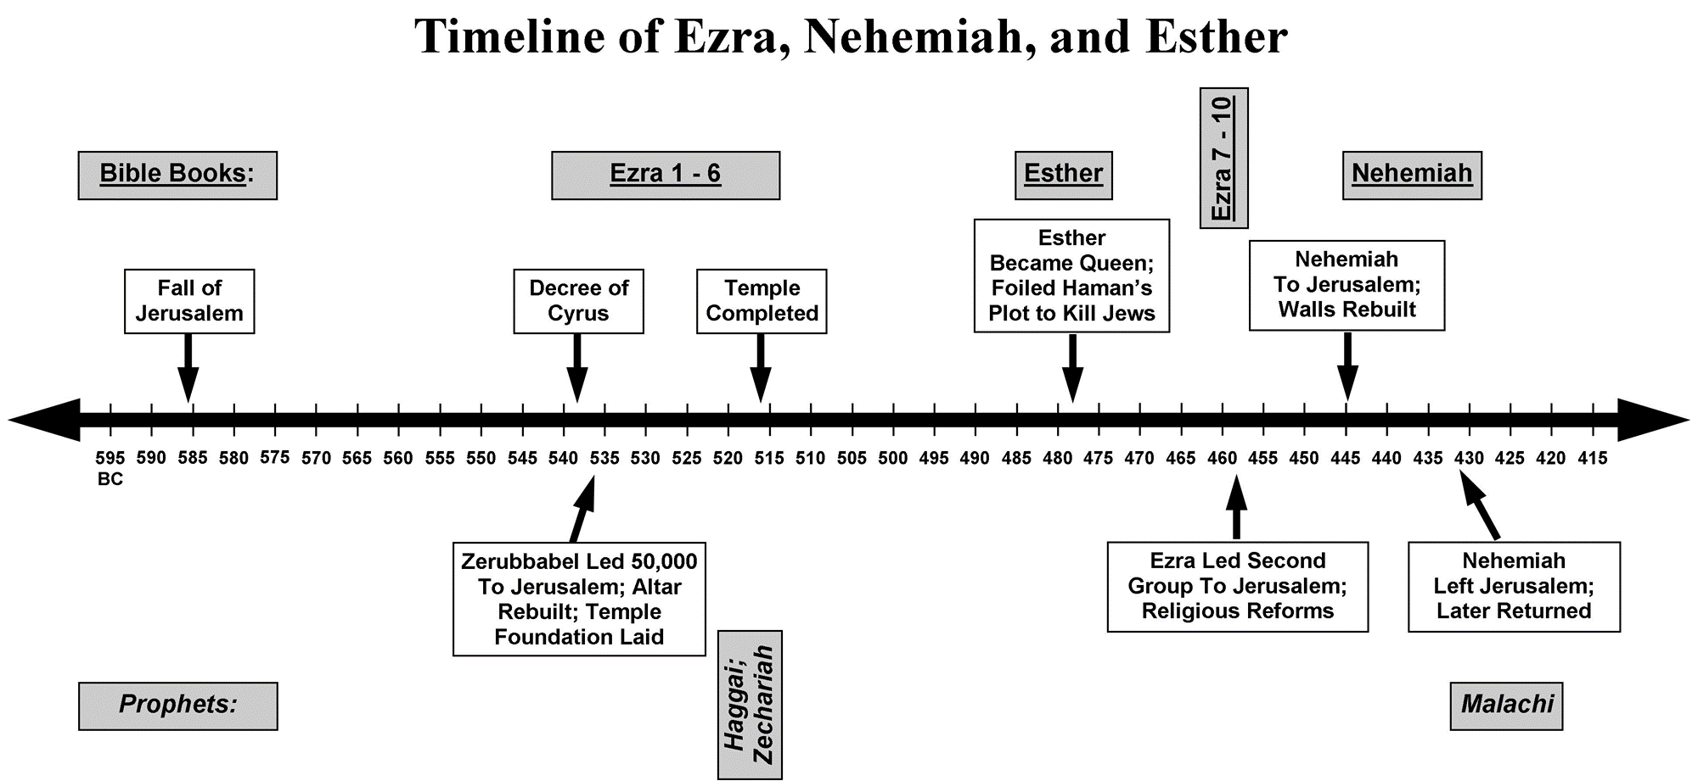
- Nehemiah hears the report (vv. 1-3)
  - 20th year of the reign of King Artaxerxes I in Chislev (Nov/Dec)
  - Susa was the winter residence of the King
  - The “Jews who had escaped” and “survived” the captivity, the “remnant” refer to Jews who had returned from __________
  - “Great distress” and “reproach” = “calamity/distress/disaster and shame/disgrace”
  - Wall is broken down (Ez. 4:12 references a partial, rebuilt wall that was apparently destroyed later by enemies – Ez. 4:23) So at the time of the report, the wall that was destroyed by the Babylonians remains broken down
- Nehemiah’s response (vv. 4-11)
  - He wept, mourned, fasted, prayed, and confessed sin “for days” (v. 4) “night and day” (v. 6)– ____ months pass between this report and when he goes to the King in 2:1
  - Why?
    - Broken city => God’s judgment => people’s sin (Deut. 4:27, 28:64)
    - Broken city represented the Israelites’ ____________ relationship with God
    - “shame/disgrace” – Why? The ___________ of Yhwh has been disgraced and the people and city remain unrestored (vv. 9, 11)
    - Deut. 30:1-10

- Nehemiah’s prayer (vv. 4-11)
  - His honoring of God (v. 5)
  - A request to hear (v. 6) – “I beseech” = a plea… “please!”
  - A confession on behalf of the people (vv. 6-7)
  - An acknowledgment of God’s warning that has come to pass (v. 8)
  - And the hope of God’s promise to ____________ (v. 9)
  - A reminder that the Israelites are God’s people (v. 10)
  - Another request to hear (v. 11a) – “please!”
  - A focus on those who “delight to revere Your name” (v. 11b)
  - An appeal that God would make his request of the King successful and that the King would show him compassion (v. 11c)
  - Mindful of Deut. 30:1-4, Nehemiah knew that the restoration was not yet complete
  - Most of Nehemiah’s pray is comprised of phrases, truths, and promises from Deuteronomy (4:27, 6:1, 7:9, 21, 9:29, 10:17, 12:5, 28:64, 30:1-4)

- Insights on Leadership
  - A leader prizes the __________ of God most of all and delights to revere His Name (vv. 9, 11)
  - A leader grieves most about broken relationships with God and things that disgrace the name of God (vv. 3, 11)
  - A leader identifies with the people under him and takes responsibility for them (vv. 6-7)
  - A leader’s first ___________ is to pray, especially in regard to confession of sin and appealing for the restoration of fellowship between loved ones and God (vv. 6-10)
  - A leader is saturated with Scripture, which governs and guides his responses (vv. 4-11)
  - A leader ____________ in prayer (1:1, 4, 2:1)

